**Setting up a profile of the Practice in CureMD**

|  |  |  |
| --- | --- | --- |
| **Step #** | **Action to Perform** | **Result** |
| 1 | Open CureMD login page and use Support user credentials  **URL:** <https://releaseapp01.curemd.com/curemd> **Credentials:** zohair/ CMDSupport2P |  |
| 2 | In the new window click on ‘Settings’ at top right corner of the screen |
| 3 | Navigate to Practice > My Practice using left tree menu |
| 4 | Update and Save following:   * Address * Contact Details * Tax ID (EIN) |
| 5 | Navigate to Practice > My Practice > Locations |
| 6 | Add and save two Locations by entering following details:   * Address * Contact Details * Place of Service |

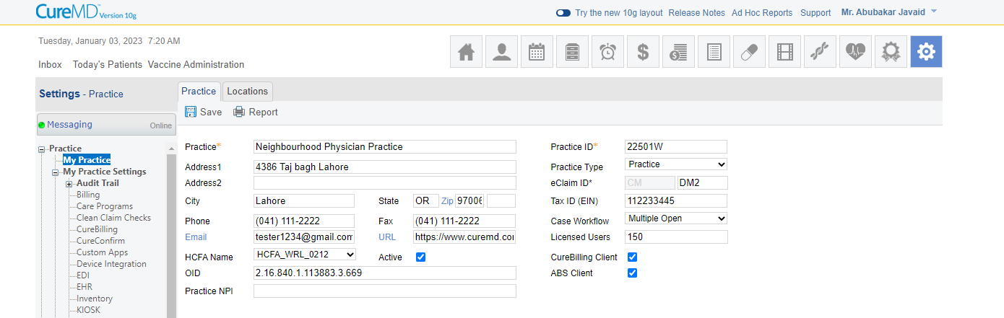

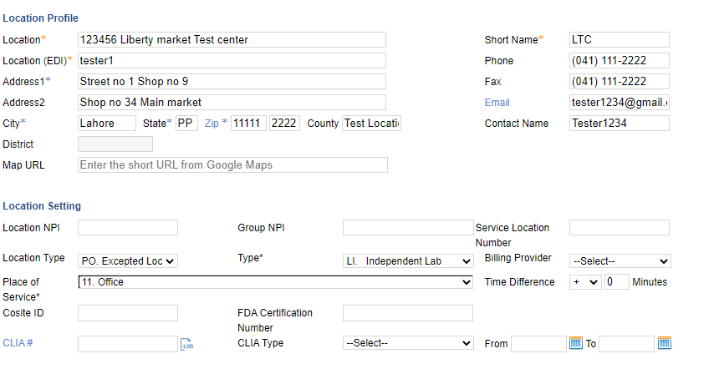

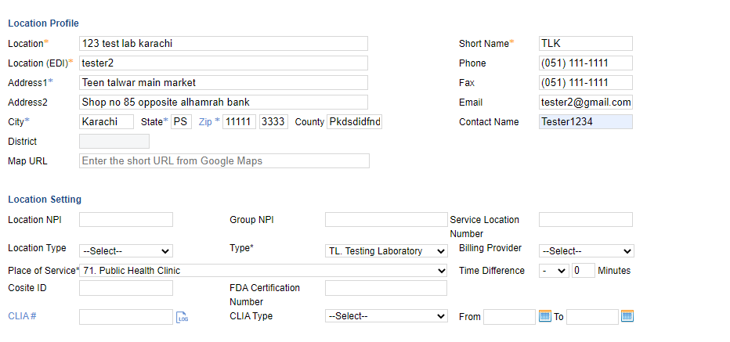

**Create a profile of the Provider and setup Provider’s Calendar**

|  |  |  |
| --- | --- | --- |
| **Step #** | **Action to Perform** | **Result** |
| 1 | Navigate to Settings > Practice > Provider > Practice Provider |  |
| 2 | Add and save Provider profile by entering following details:   * Name * SSN * NPI * License Type * Address * Contact Details * Specialty * Provider type (Billing, Rendering/Attending) |
| 3 | Navigate to Settings > Practice > Provider > Provider Profile > Schedule |
| 4 | Add and save a new Calendar  Make sure to create a realistic schedule |
| 5 | Navigate to Settings > Practice > Provider > Provider Profile > Block Schedule |
| 6 | Add and save Schedule Block as follow   * Name/Reason of the Block (Lunch) * What date range the block will be valid for * The time/slots the block must appear |

**Query:** I want to know about the purpose of block schedule

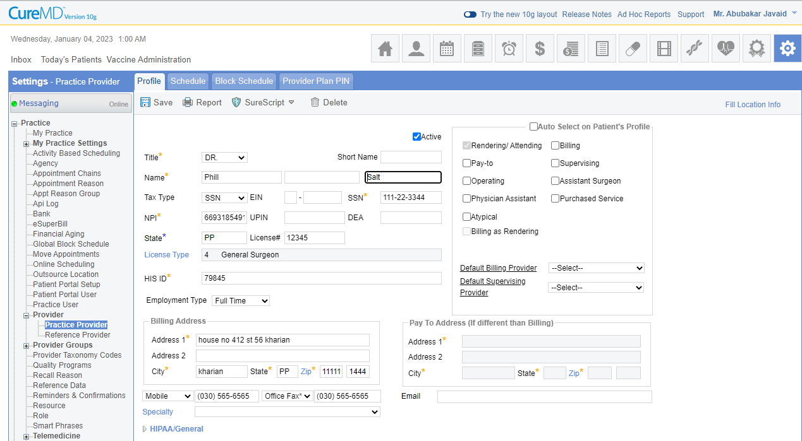

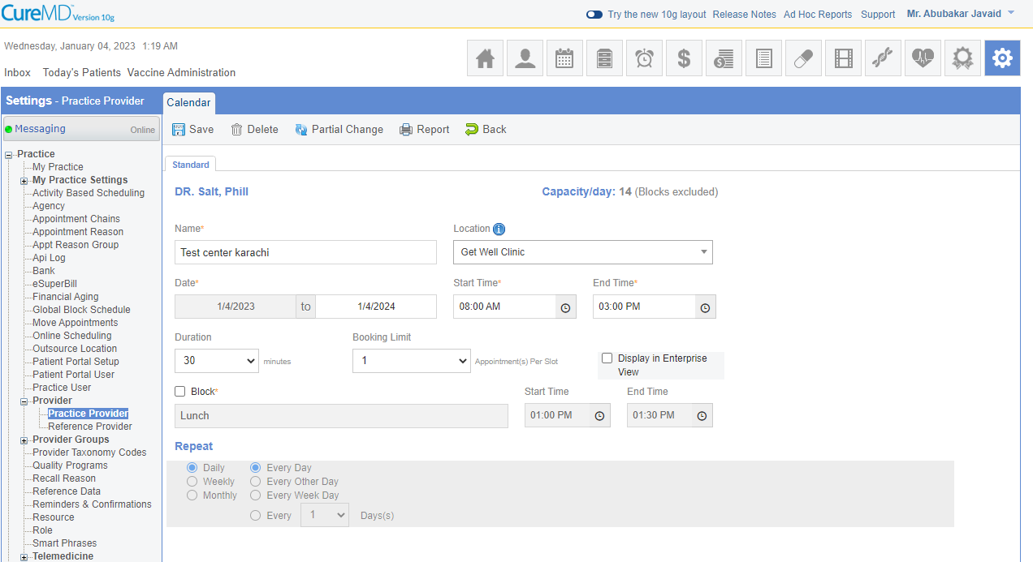

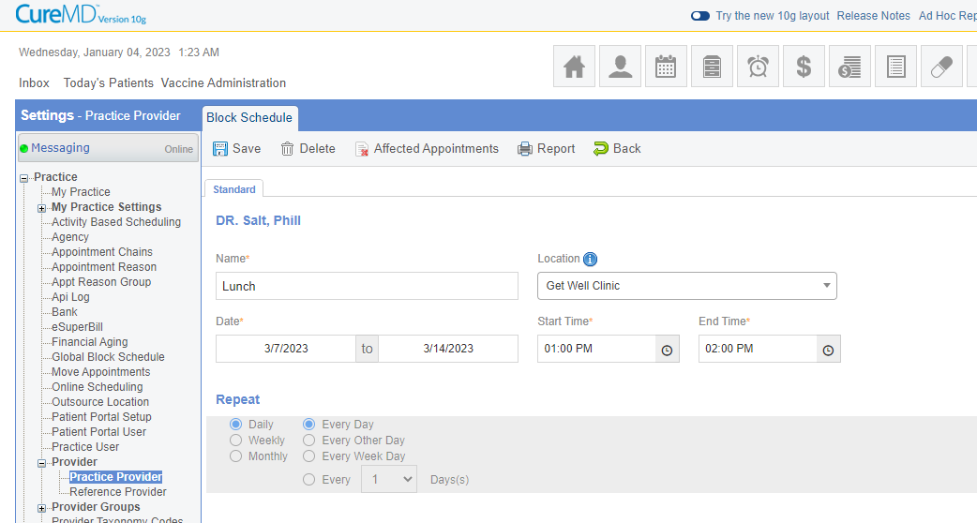

**Create a profile of the Resource and setup Resource’s Calendar**

|  |  |  |
| --- | --- | --- |
| **Step #** | **Action to Perform** | **Result** |
| 1 | Navigate to Settings > Practice > Resource |  |
| 2 | Add and save Provider profile by entering following details:   * Name * Provider |
| 3 | Navigate to Settings > Practice > Resource > Schedule |
| 4 | Add and save a new Calendar  Make sure to create a realistic schedule |
| 5 | Navigate to Settings > Practice > Resource > Block Schedule |
| 6 | Add and save Schedule Block as follow   * Name/Reason of the Block (Lunch) * What date range the block will be valid for * The time/slots the block must appear |

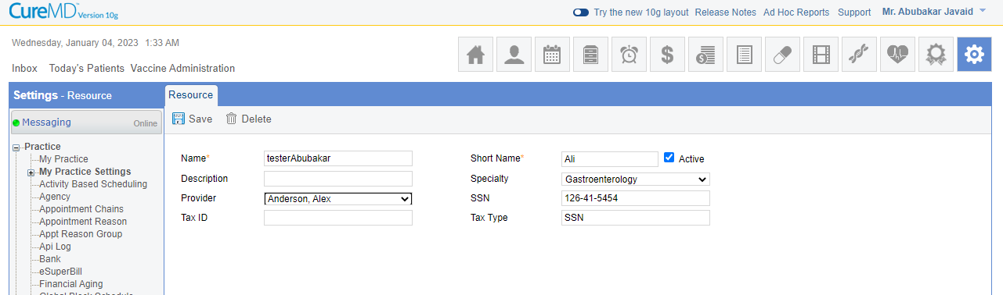

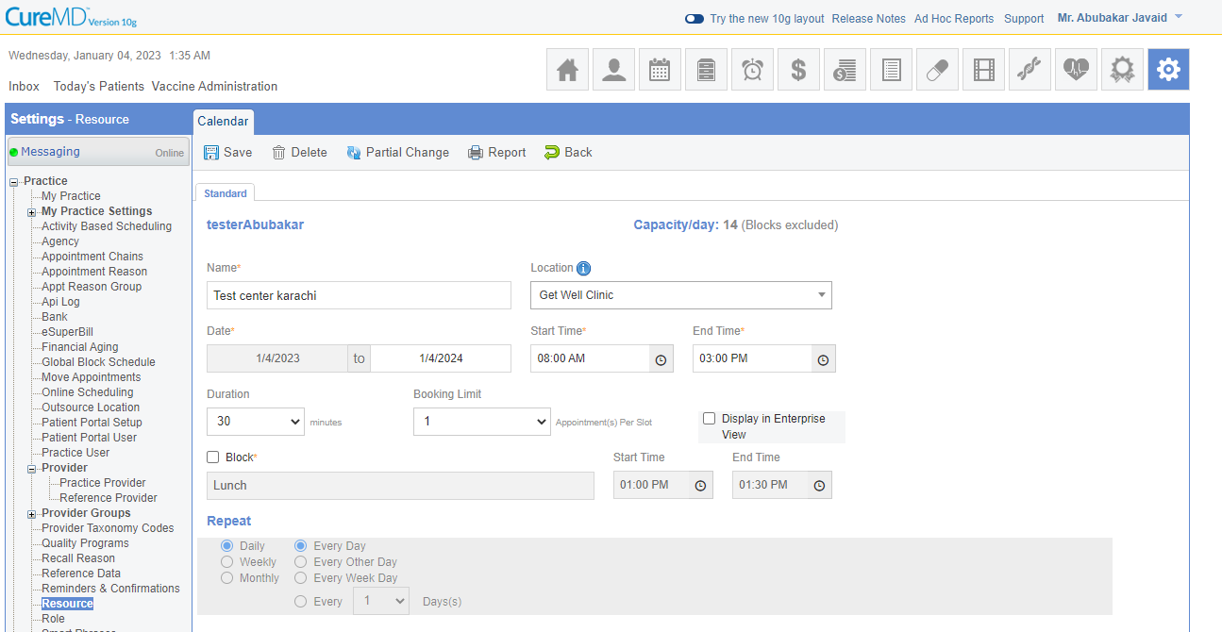

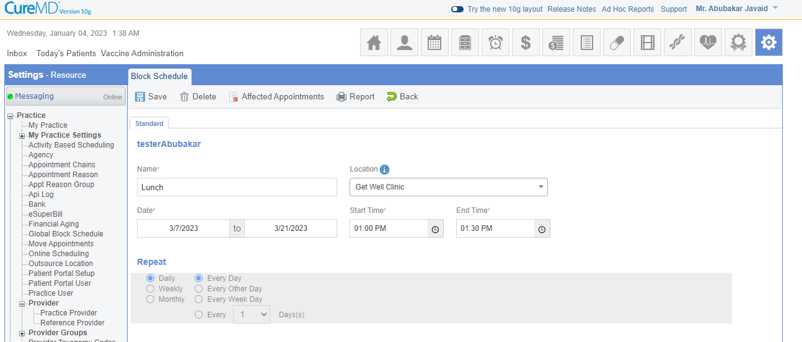

**A User Logs in using the Office Manager’s account to create his own account and then uses his own account to schedule a new patient.**

|  |  |  |
| --- | --- | --- |
| **Step #** | **Action to Perform** | **Result** |
| 1 | Log into CureMD Application. Take credentials (URL, Username and Password) from your TL/PM |  |
| 2 | Go-to Settings module from top navigation |
| 3 | From the left selection panel, Expand Practice. |
| 4 | Click ‘Practice User’ option |
| 5 | Click ‘Add User’ action button at the top |
| 6 | Enter the following information in User’s Demographics:   1. Select Title as ‘Miss’ 2. Enter User’s First Name, Middle Initial and Last Name 3. Enter Date of Birth 4. Select Gender 5. Enter Address Line 1 6. Enter City, State and Zip 7. Enter User’s valid email address 8. Select multiple locations in Location drop down 9. Enter User’s phone number 10. Enter new Username and Password 11. Enter Secret Question with Answer 12. Select User Role as ‘Reception’ 13. Don’t associate any Providers with the user 14. Don’t change the Active status of the user 15. Select ‘Use my Location as default for Patient’s Demographics. |
| 7 | Click Save |
| 8 | Click ‘Permissions’ tab on the top |
| 9 | Give following rights to User:   1. Personal 2. Patient 3. Add Patient 4. Billing 5. Demographics 6. Scheduling 7. Scheduler 8. Check In |
| 10 | Click Save and Log out |
| 11 | Log in as the new user you have just created. |

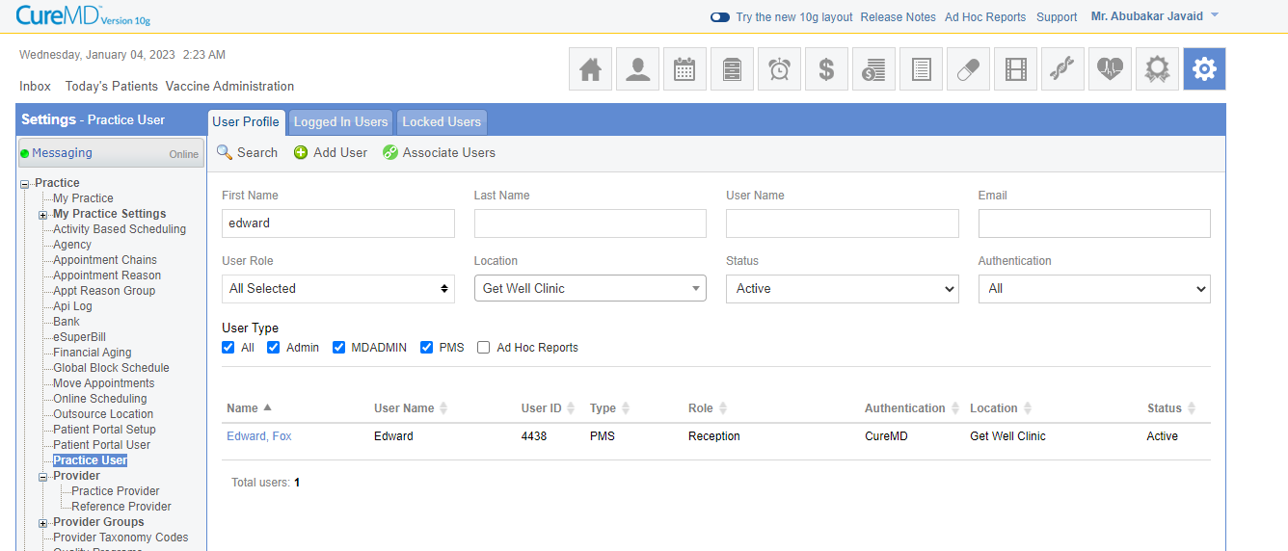

|  |  |  |
| --- | --- | --- |
| **12a.** | **Go to Patients module at the Top.** |  |
| 13 | Click on ‘Add’ button at the top |
| 14 | Enter the following information in Patient’s Demographics:   1. Select Title as ‘Miss’ 2. Enter User’s First Name, Middle Initial and Last Name 3. Enter Date of Birth 4. Select Gender 5. Enter Address Line 1 6. Enter the SSN as 123456789 7. Enter City, State and Zip 8. Enter Patient’s valid email address 9. Select location in Location drop down 10. Enter the Patient’s Contact number. |
| 15 | Enter the following Primary Insurance info   1. Mark the checkbox ‘Include Primary Insurance’ 2. Select the Plan name ‘Medicare’ from the drop down. 3. Select the Address from the drop down. 4. Enter the Policy Number as ‘123456789’ 5. Enter the Group Number ‘abc123’ 6. Enter the copay amount as $10 7. Select the Insured Party as ‘Self’ |
| 16 | Enter the following Secondary Insurance info   1. Mark the checkbox ‘Include Secondary Insurance’ 2. Select the Plan name ‘Aetna’ from the drop down. 3. Select the Address from the drop down. 4. Enter the Policy Number as ‘1234567A’ 5. Enter the Group Number ‘xyz123’ 6. Enter the copay amount as $10 7. Select the Insured Party as ‘Self’ |
| 17 | Click on Save & Schedule |
| 18 | From the left selection panel, select the Provider |
| 19 | Select the date from the calendar |
| 20 | Click on the white space for the time you want to schedule the appointment (Today) |
| 21 | Select the status as Scheduled |
| 22 | Select the reason as ‘Follow up’ for appointment |
| 23 | Click on ‘Schedule’ button |
| 24 | Click on the scheduled appointment |
| 25 | Select ‘check-in’ option |
| 26 | The copay amount is $10. Mark it as paid. Save. |
| 27 | Click on scheduled (Checked in) appointment |
| 28 | Click on check out. Save. |

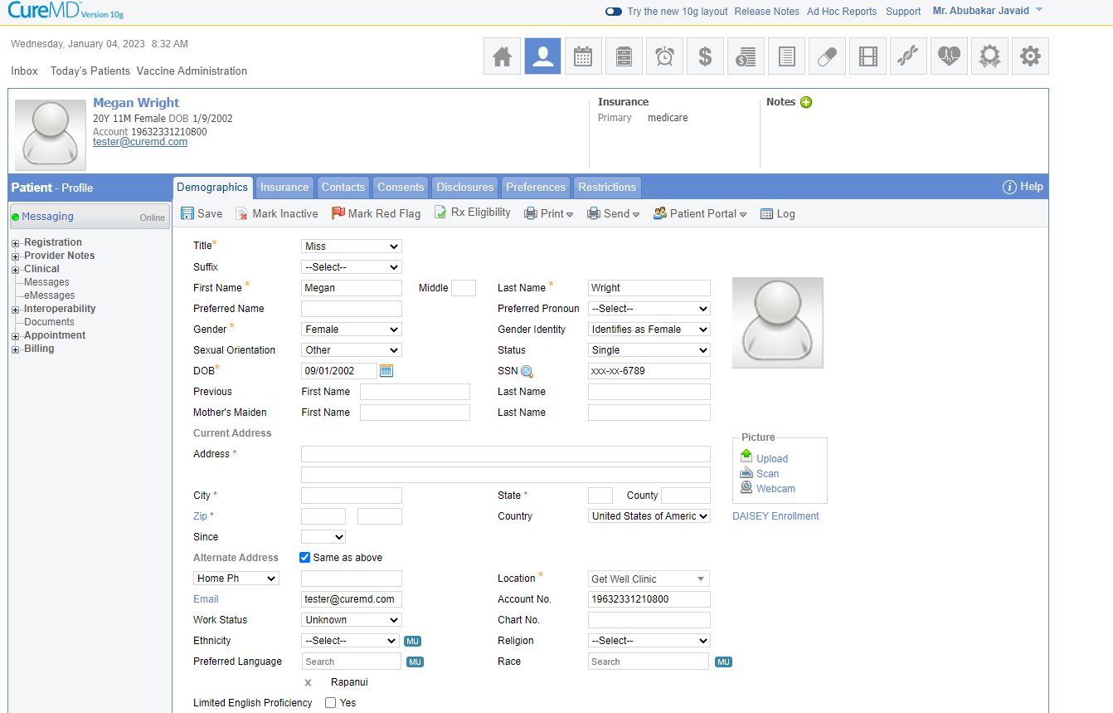

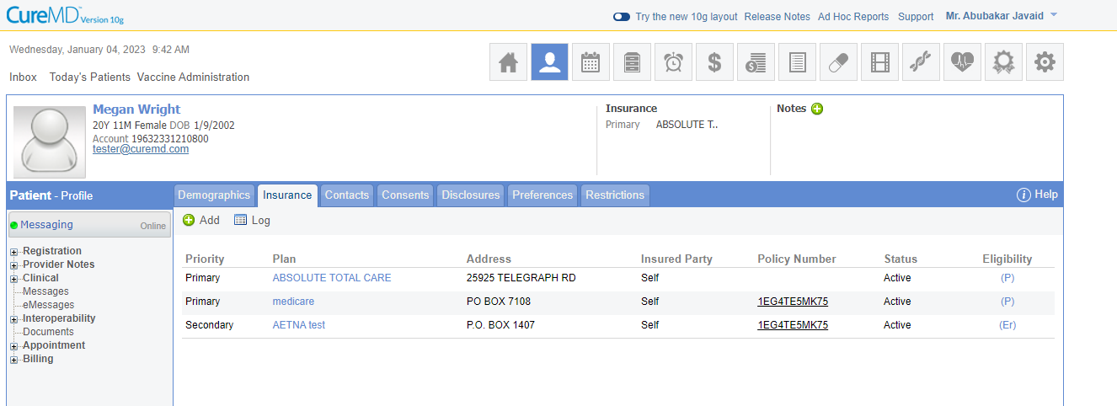

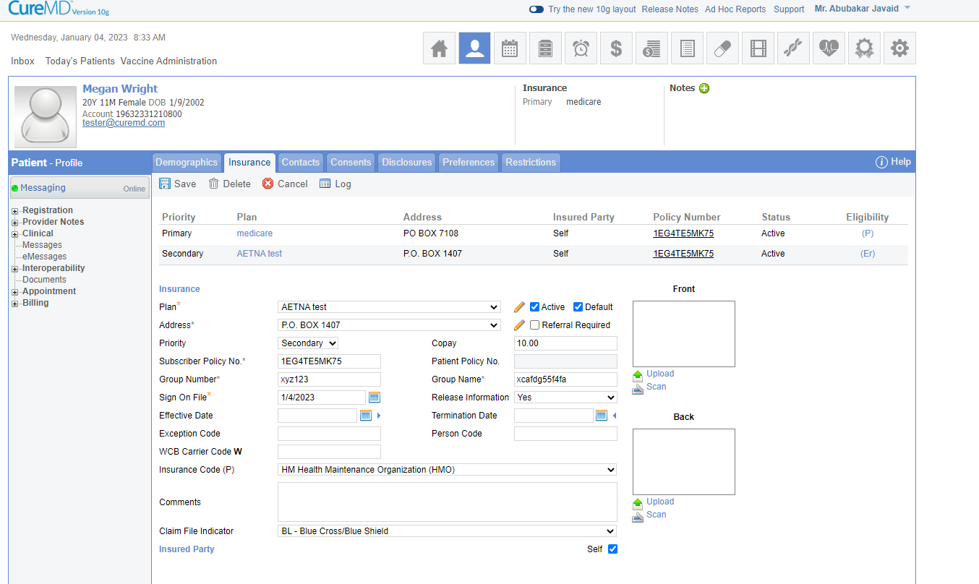



|  |  |  |
| --- | --- | --- |
| **12b.** | **Go to Scheduler Module** |  |
| 13 | From the left selection panel, select the Provider |
| 14 | Select the date |
| 15 | Click on the white space for the time you want to schedule the appointment (Today) |
| 16 | On the Appointment window opened on the right, click on Quick Add |
| 17 | Enter the following information in Patient’s Demographics:   1. Select Title as ‘Miss’ 2. Enter User’s First Name, Middle Initial and Last Name 3. Enter Date of Birth 4. Select Gender 5. Enter Address Line 1 6. Enter City, State and Zip 7. Enter Patient’s valid email address 8. Select location in Location drop down 9. Enter the Patient’s Contact number   Click Save. |
| 18 | Click on ‘Insurance’.  Then, click on ‘Add’. |
| 19 | Enter the following insurance info   1. Select the Plan name from the drop down. 2. Select the Address from the drop down. 3. Enter the Policy Number 4. Enter the Group Number 5. Enter the copay amount as $20 6. Do not uncheck the ‘Active’ checkbox |
| 20 | Uncheck ‘Self’ box for Insured Party. |
| 21 | Enter the following details for the Patient’s Spouse:   1. Select the Title as ‘Miss’ 2. Select the Relationship as ‘Spouse’ from the drop down 3. Enter First name, Middle Initial and Last name 4. Enter a 10 digit SSN 5. Enter a valid email ID 6. Enter Address Line 1 7. Enter City, State and Zip 8. Enter Phone number |
| 22 | Click Save. Then, click Continue. |
| 23 | Select the status as Scheduled |
| 24 | Select the reason as ‘Follow Up’ |
| 25 | Click on Schedule |
| 26 | Click on the scheduled appointment for the same patient |
| 27 | Select check-in |
| 28 | The copay amount is $20. Mark it as paid. Save. |
| 29 | Click on scheduled (Checked in) appointment |
| 30 | Click on check out. Save. |

**Query:** Whenever I save the insurance information it gives me error “Subscriber group name not allowed”.

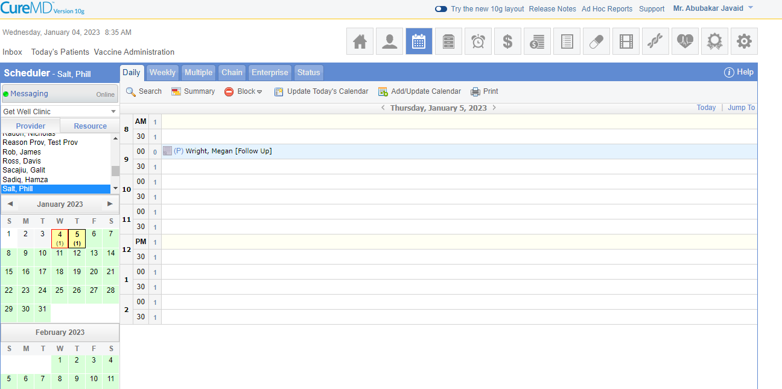

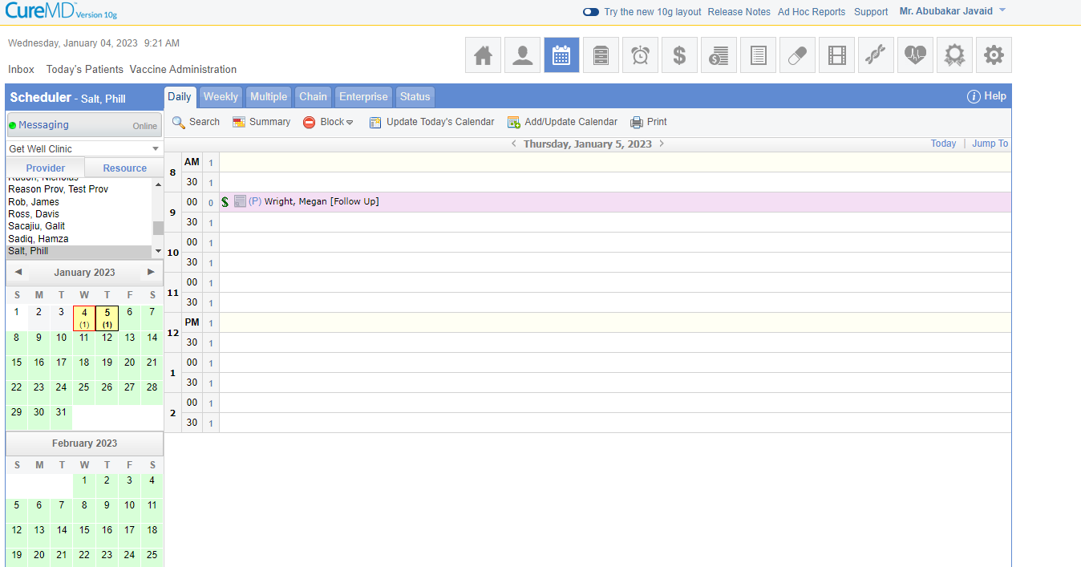

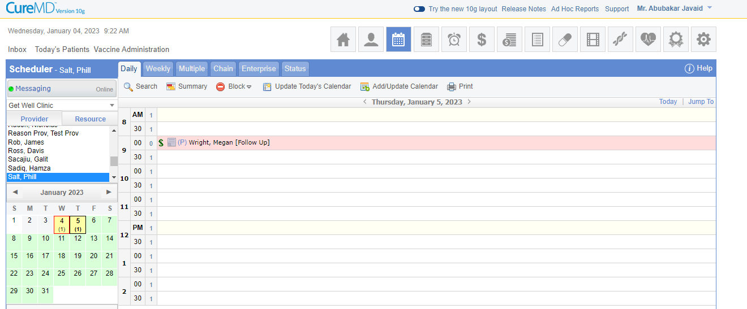

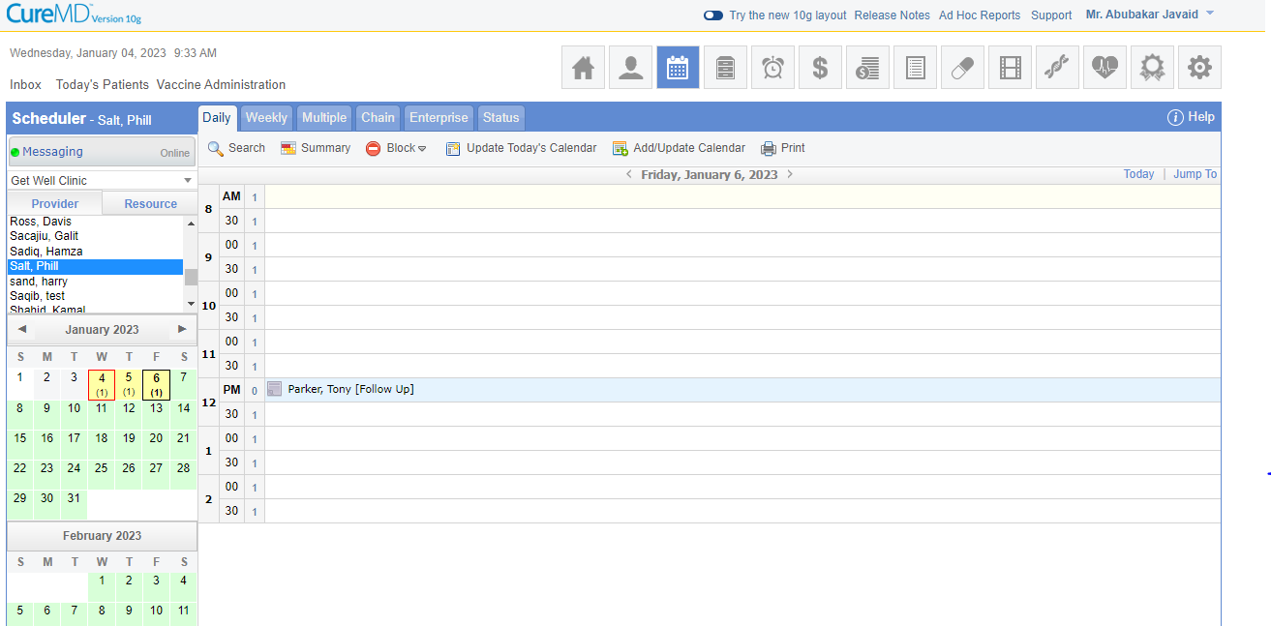

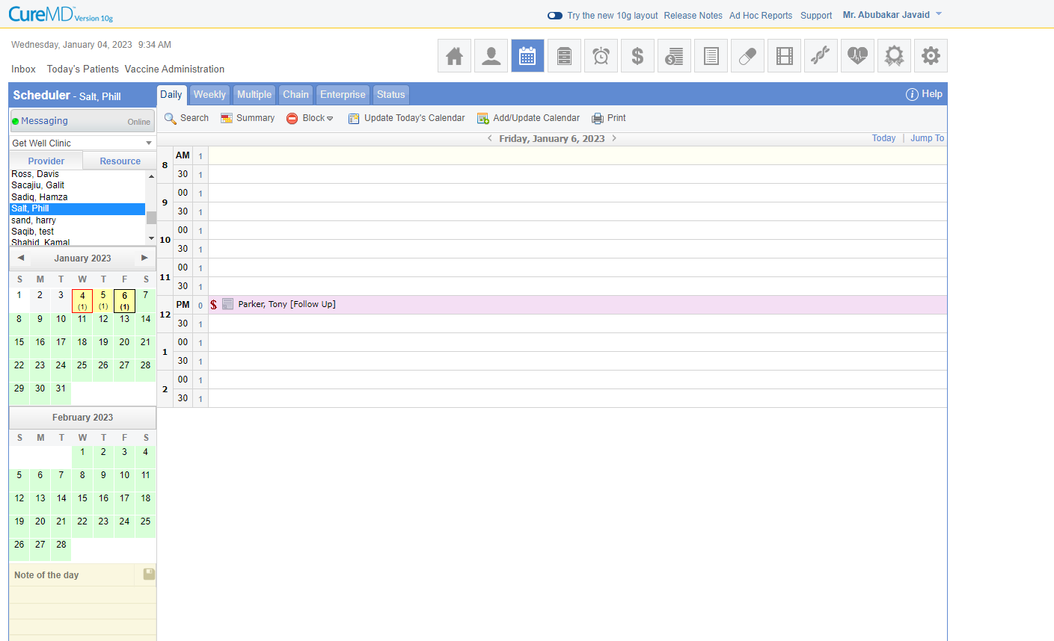

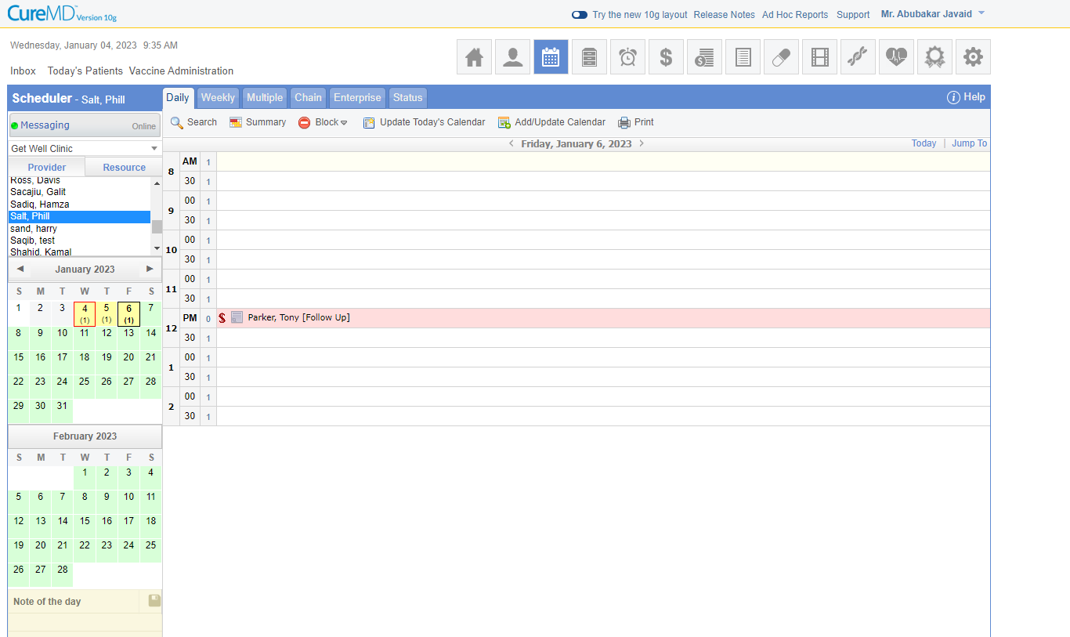

**Nurse practitioner is logged in the application to record the subjective and objective assessment of the patient.**

|  |  |  |
| --- | --- | --- |
| **Step #** | **Action to Perform** | **Result** |
| 1 | Give following rights to User from permission tab:   1. Personal 2. Patient 3. Add Patient 4. Billing 5. Demographics 6. Scheduling 7. Scheduler 8. Check In 9. Clinical |  |
| 2 | Give following rights to User from My Preferences:   1. Default landing page ‘Today’s Patient’ |
| 3 | Click Save and Log out |
| 4 | Log in as the nurse practitioner user you have just created. |
| **5** | **Today’s Patient** |
| 6 | Change the status from Check-in to Pre-exam |
| 7 | Navigate to Patient>Clinical |
| 8 | Add ‘Allergies’ |
| 9 | Go to Add Allergen |
| 10 | Select required allergy |
| 11 | Enter following for the selected allergy   1. Severity 2. OnSet 3. Comments (If required) |
| 12 | Click Save |
| 13 | Add ‘Vitals’ |
| 14 | Enter following when recording the vitals   1. Weight 2. Height 3. Blood Pressure |
| 15 | Click Save |

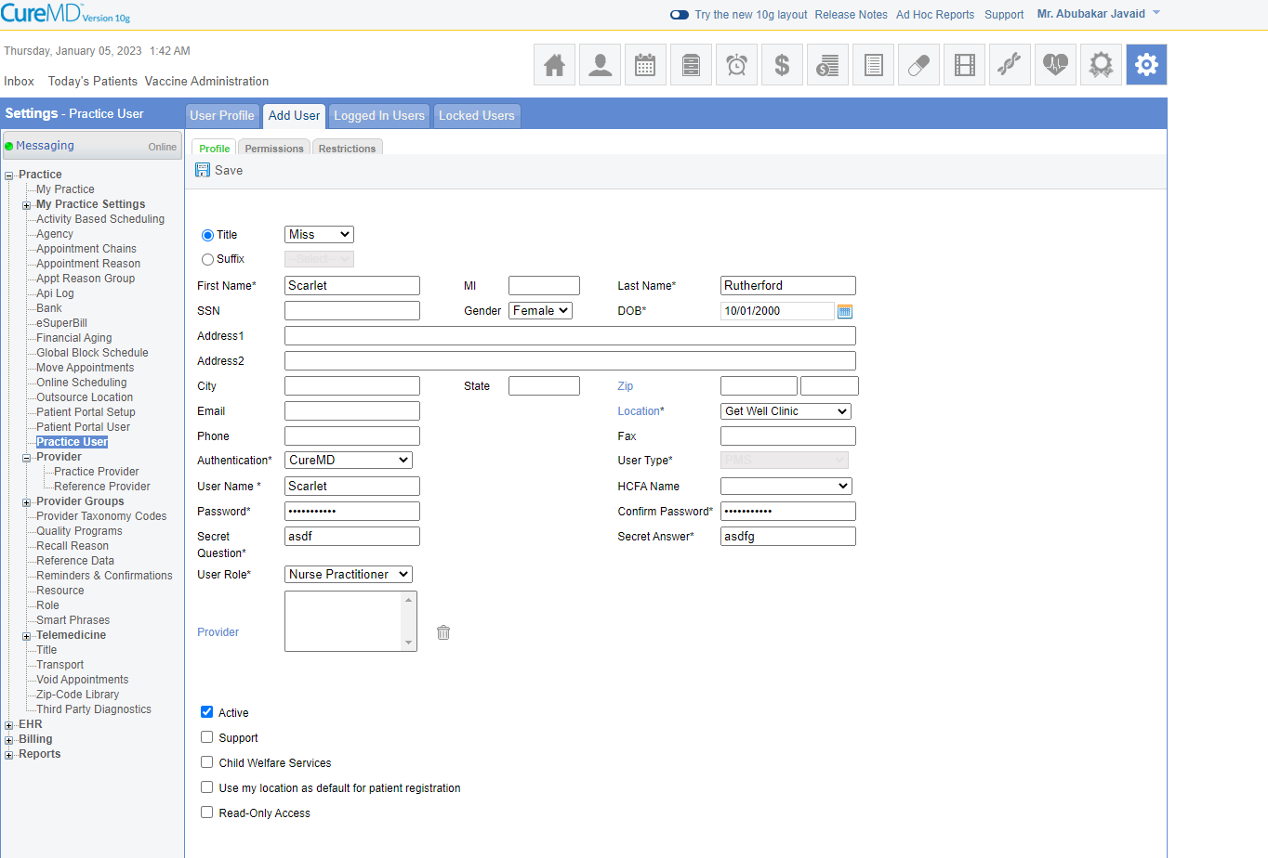

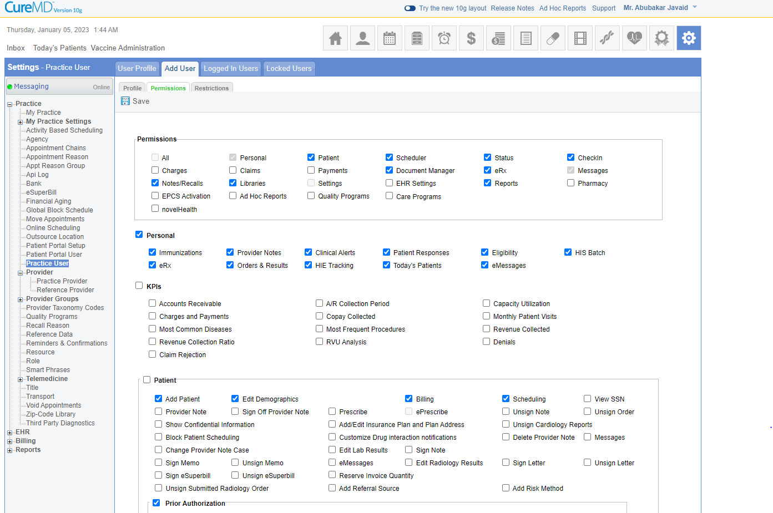

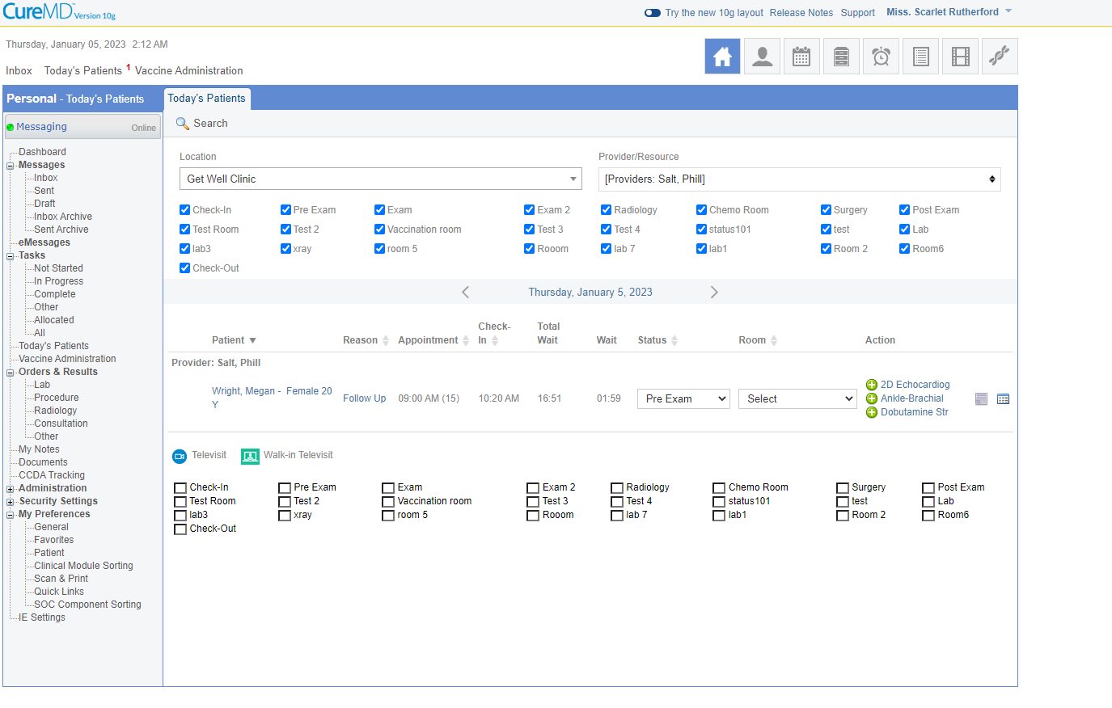

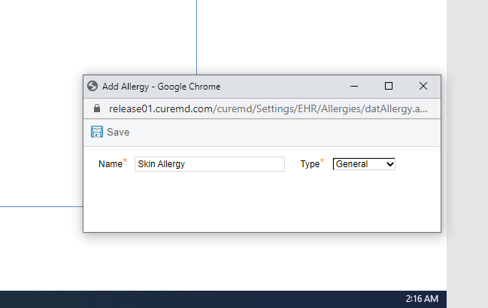

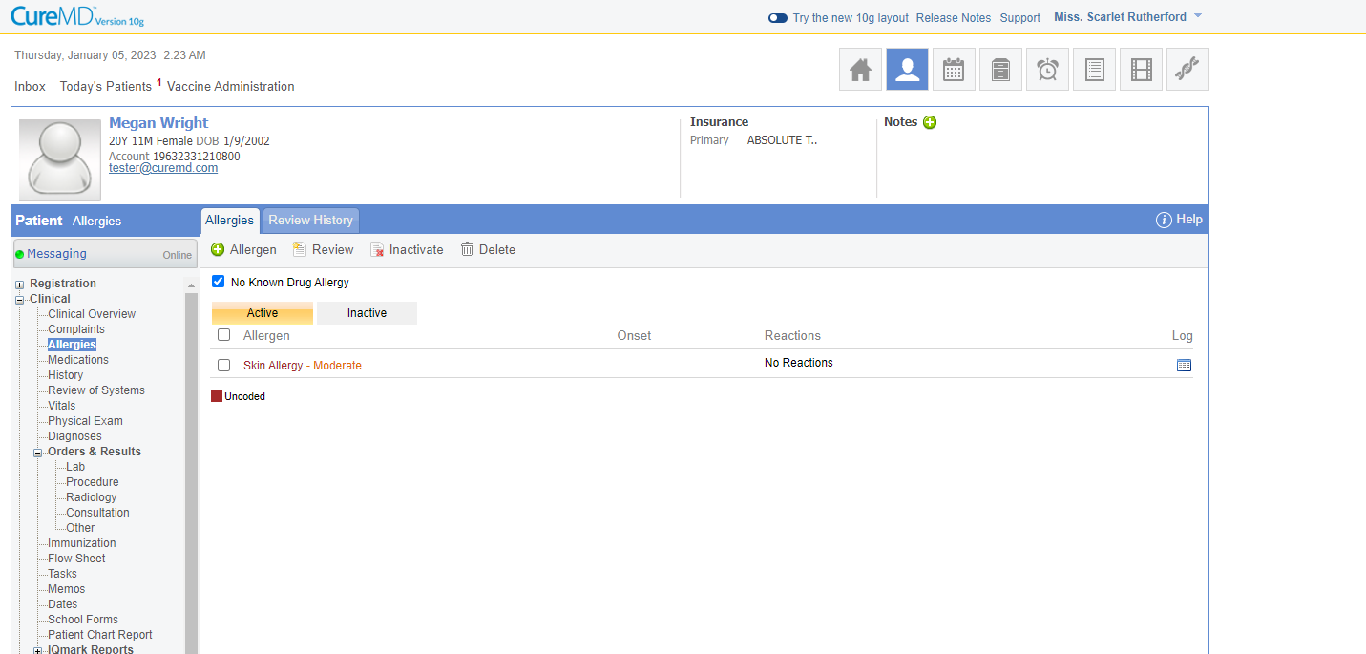

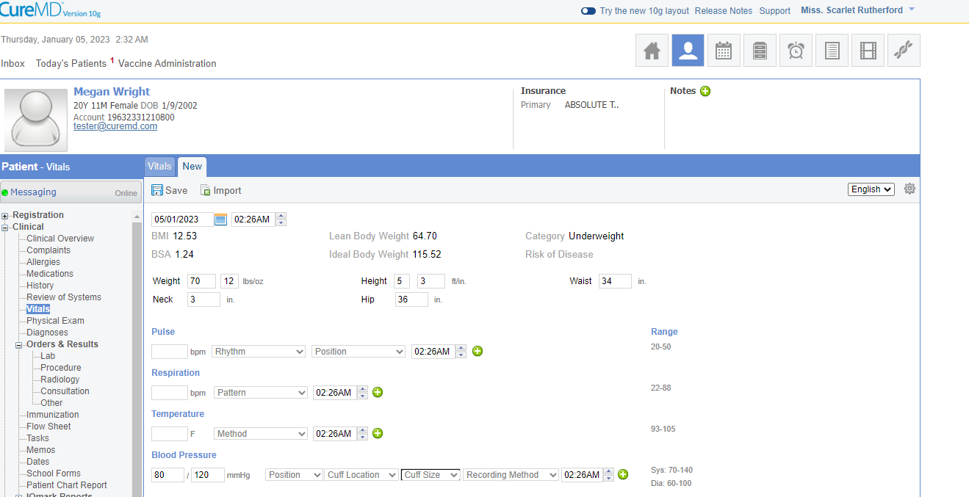

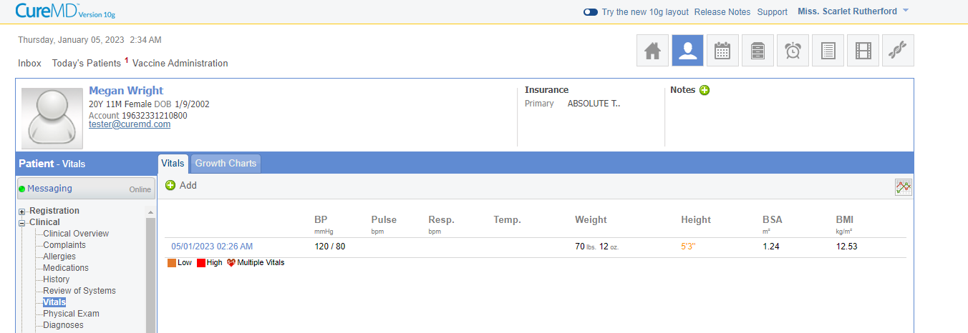

**Doctor i.e Provider will be logged in the application**.

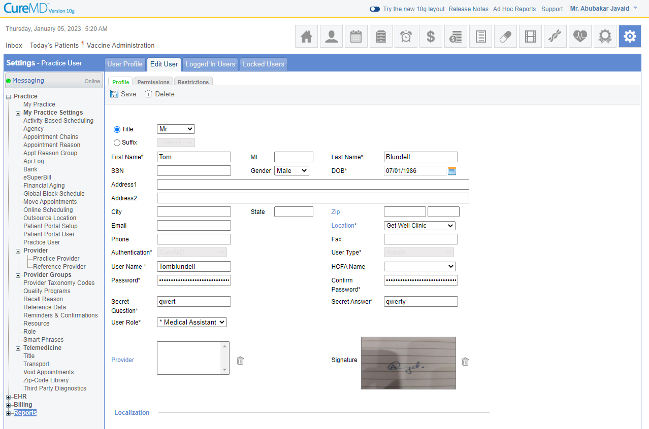

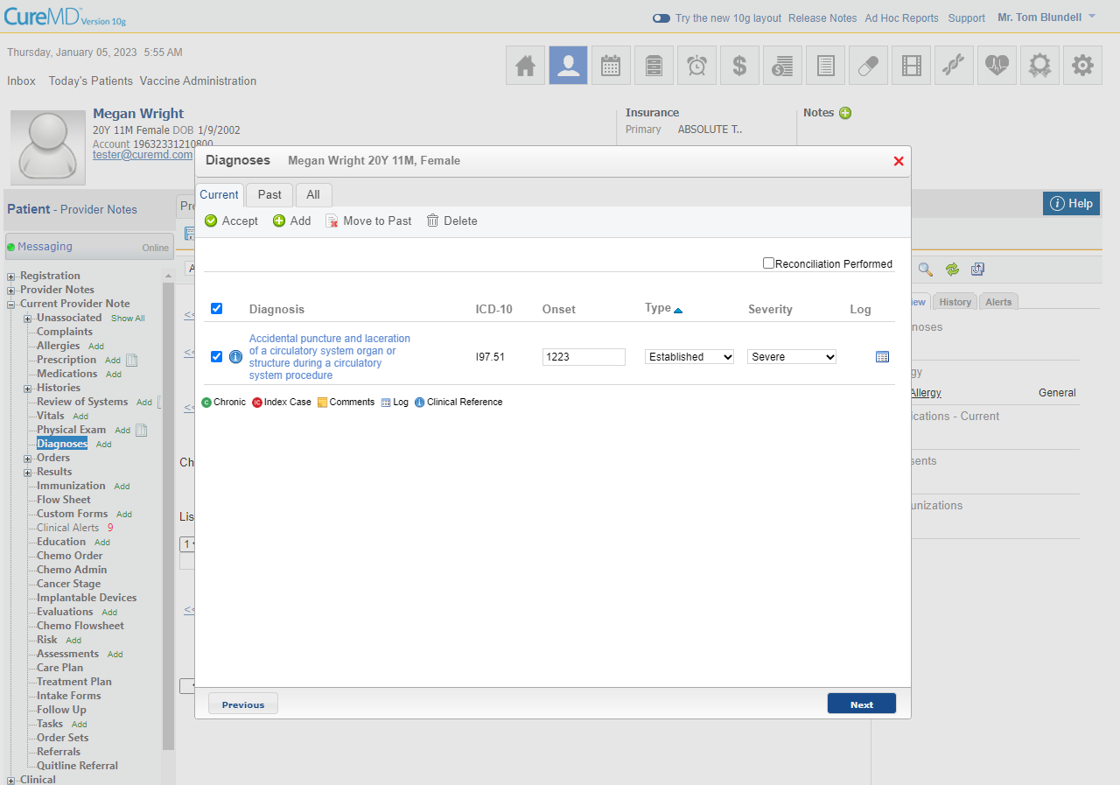

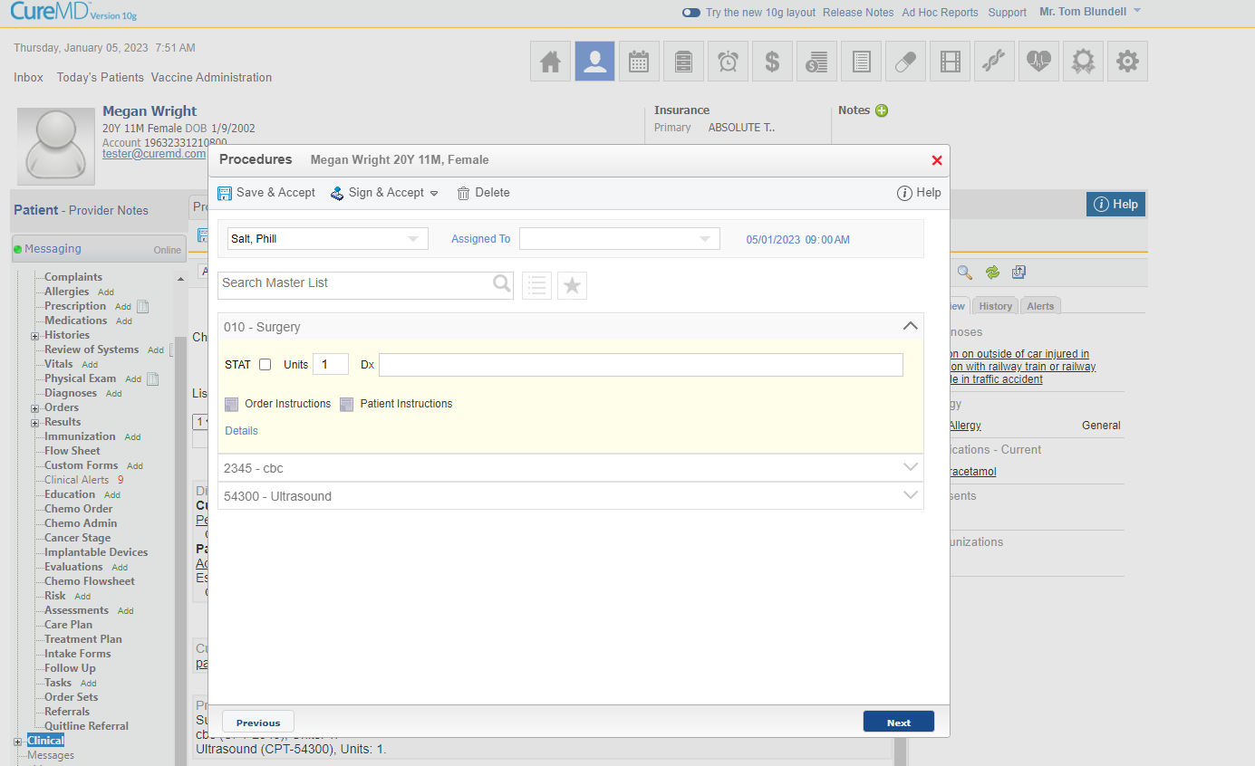

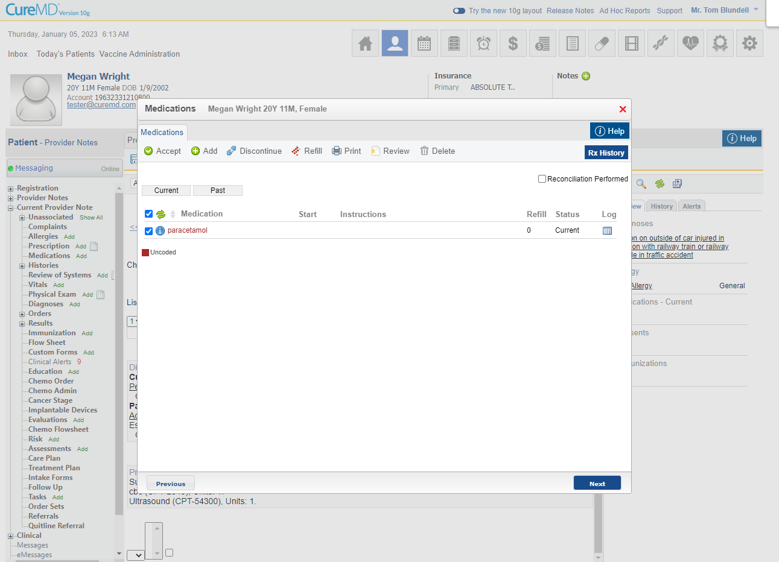

**ESuperbill**

**User log in to the application using biller’s account to create eSuperbill from provider note**

**All Diagnosis and CPTs added on provider note should automatically populate on eSuperbill**

|  |  |  |
| --- | --- | --- |
| **Step #** | **Action to Perform** | **Result** |
| 1 | Click Diagnosis – ICDs link |  |
| 2 | Search and select the required ICD code |
| 3 | Check the E&M code checkbox. |
| 4 | Click Procedures-CPTs link |
| 5 | Add modifiers against CPT |
| 6 | Add Diagnosis Pointers (Dx. Ptr*) |
| 7 | Enter Comments |
| 8 | Click Save & Sign |
| 9 | Click Report button |
| 10 | Click “Create Charge” |

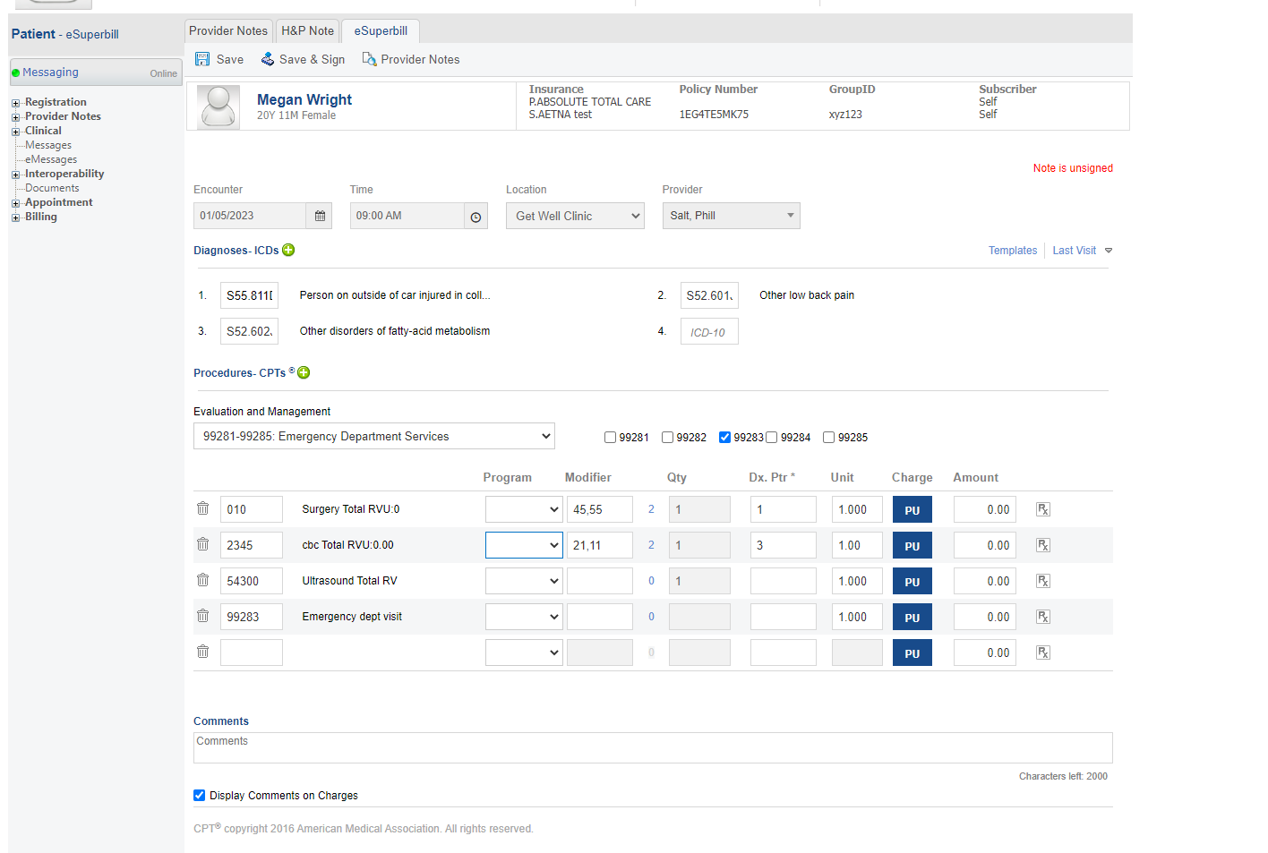

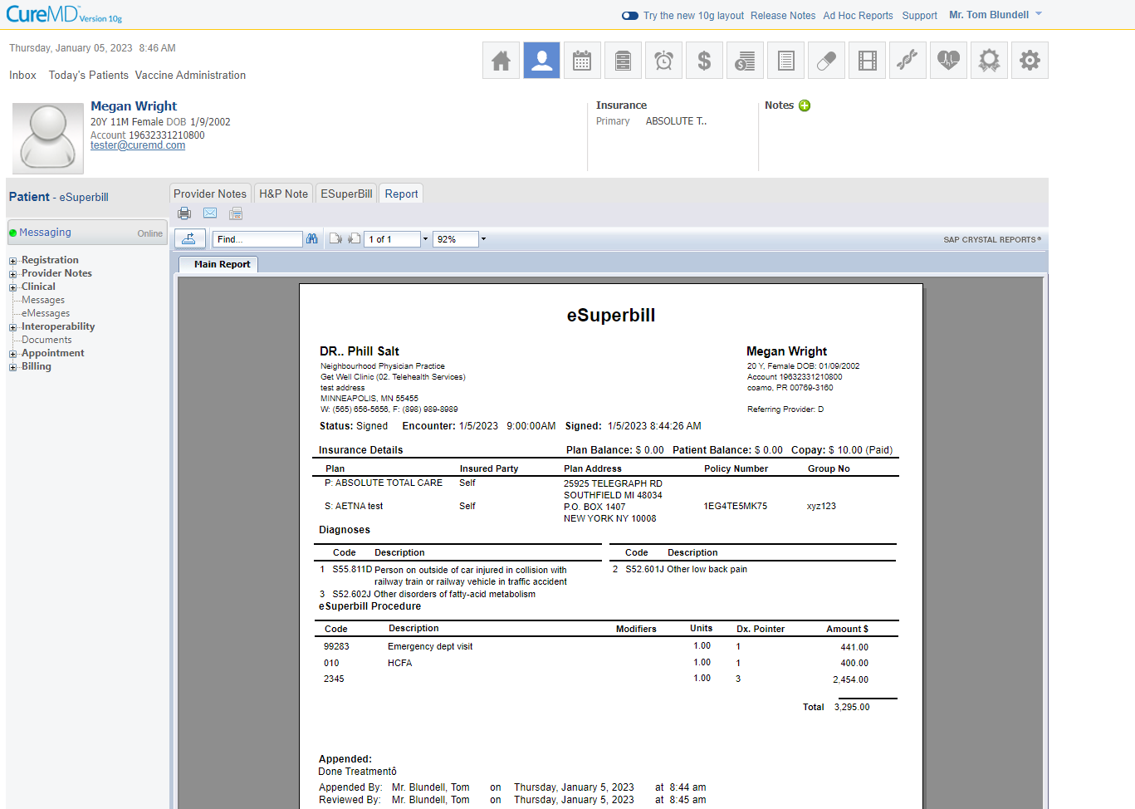

**Charge**

**All Diagnosis and CPTs added on eSuperbill should automatically populate on Charge**

**Provider and Location are also added on Charge from eSuperbill**

**Query:**  I did not understand modifiers and Diagnosis pointers.

|  |  |  |
| --- | --- | --- |
| 11 | Select Primary & Secondary Insurances |  |
| 12 | Select Rendering Provider from “Rendering” dropdown |
| 13 | Select Billing provider from “Billing” dropdown |
| 14 | Click “Diagnosis” link |
| 15 | Search and select the required ICD code |
| 16 | Click “Procedures” link |
| 17 | Add modifiers against CPT |
| 18 | Add Diagnosis Pointers (Dx. Ptr*) |
| 19 | Select Insurance from “Responsible Plan” dropdown |
| 20 | Click “Save” |
| 21 | Select “Payment” from Payment dropdown |
| 22 | Select “Professional” from Claim dropdown |

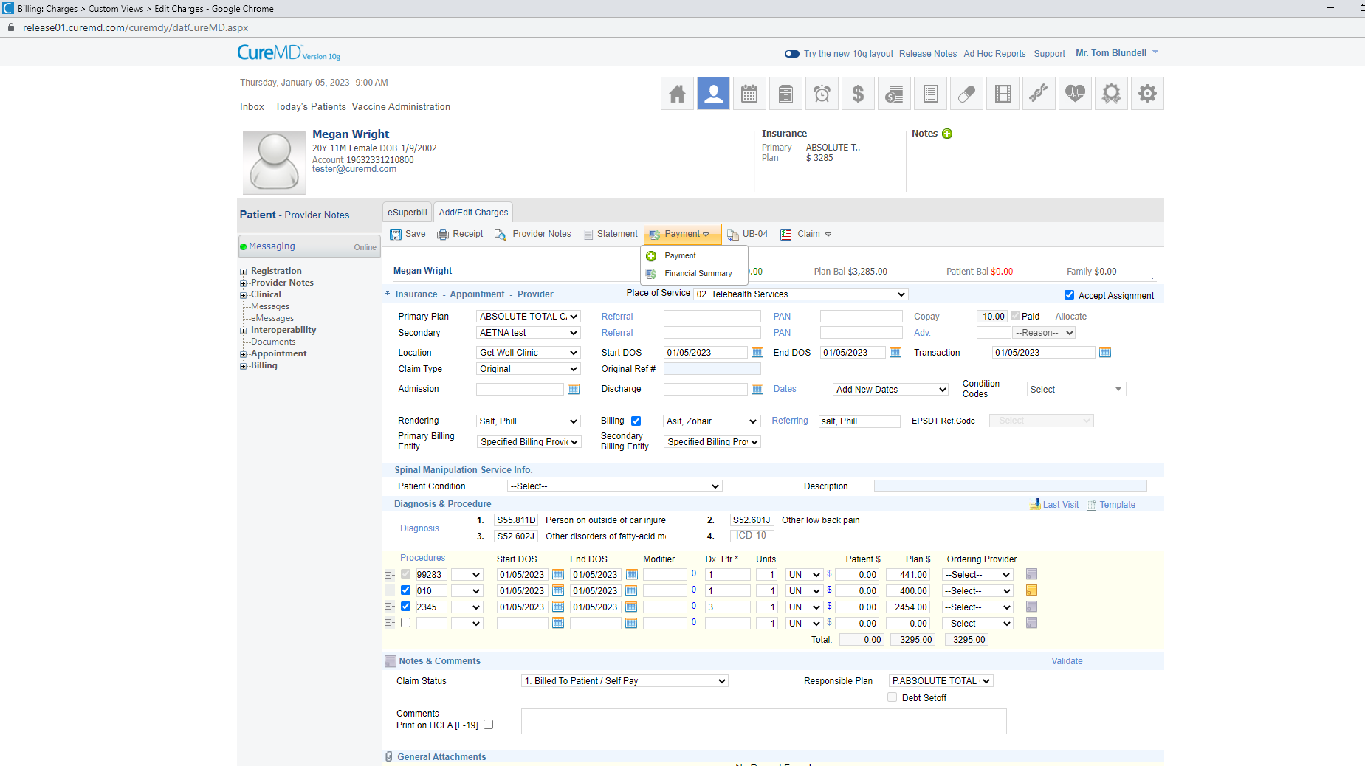

**Claim Generation**

**Different types of claims can be generated depending upon the type of Insurance**

|  |  |  |
| --- | --- | --- |
| 23 | Click “EDI Claim” |  |
| 24 | Select HCFA type from dropdown |
| 25 | Click “Preview button” |

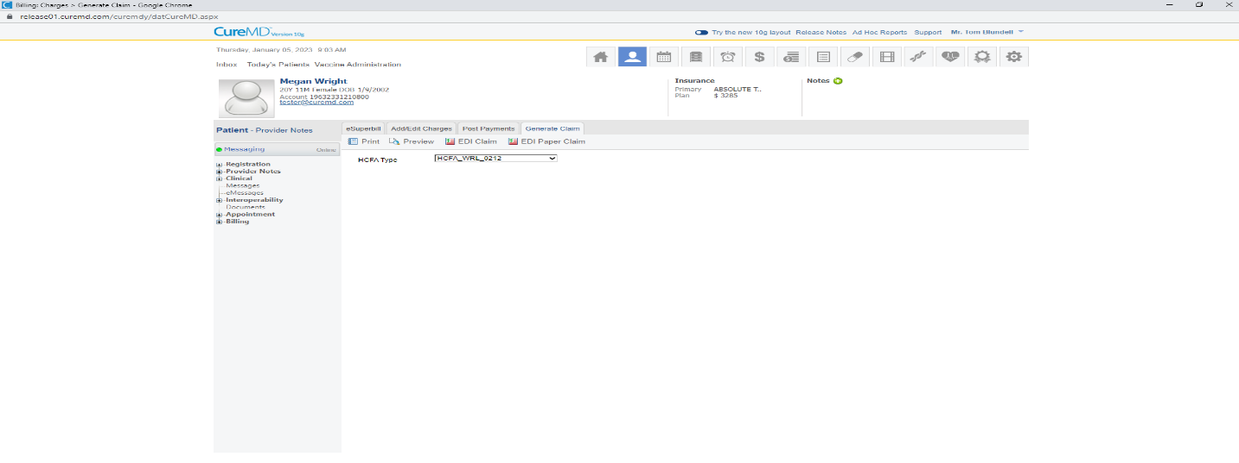

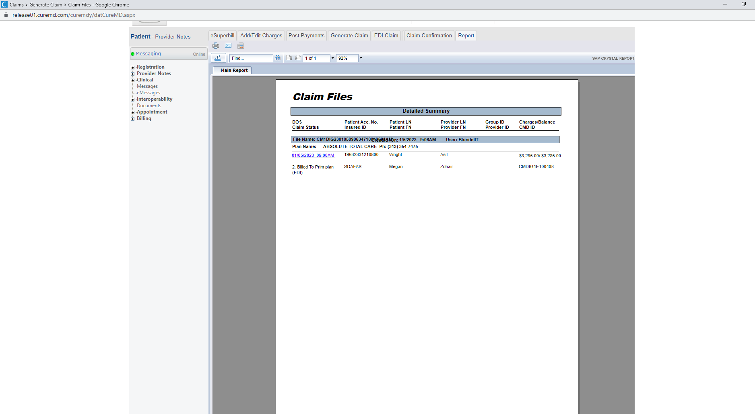

|  |  |  |
| --- | --- | --- |
| 26 | Select “Primary Insurance” from Payment By dropdown |  |
| 27 | Select Payment method |
| 28 | Enter allowed amount |
| 29 | Enter Paid amount |
| 30 | Enter Transfer amount |
| 31 | Select next responsible |
| 32 | Click “Save” |
| 33 | Repeat step 28 to 32 to complete the payments |
| 34 | Click “Statement” button |
| 35 | Select statement template from “Template” dropdown |
| 36 | Check “Statement” radio button |
| 37 | Click “Preview” button |

